Coding Three: Web Development Studio

Documentation
Initial page version; wanted self interview style to reflect my authenticity; very barebones but a good start; 3 positional classes and a 4th class for the final font.
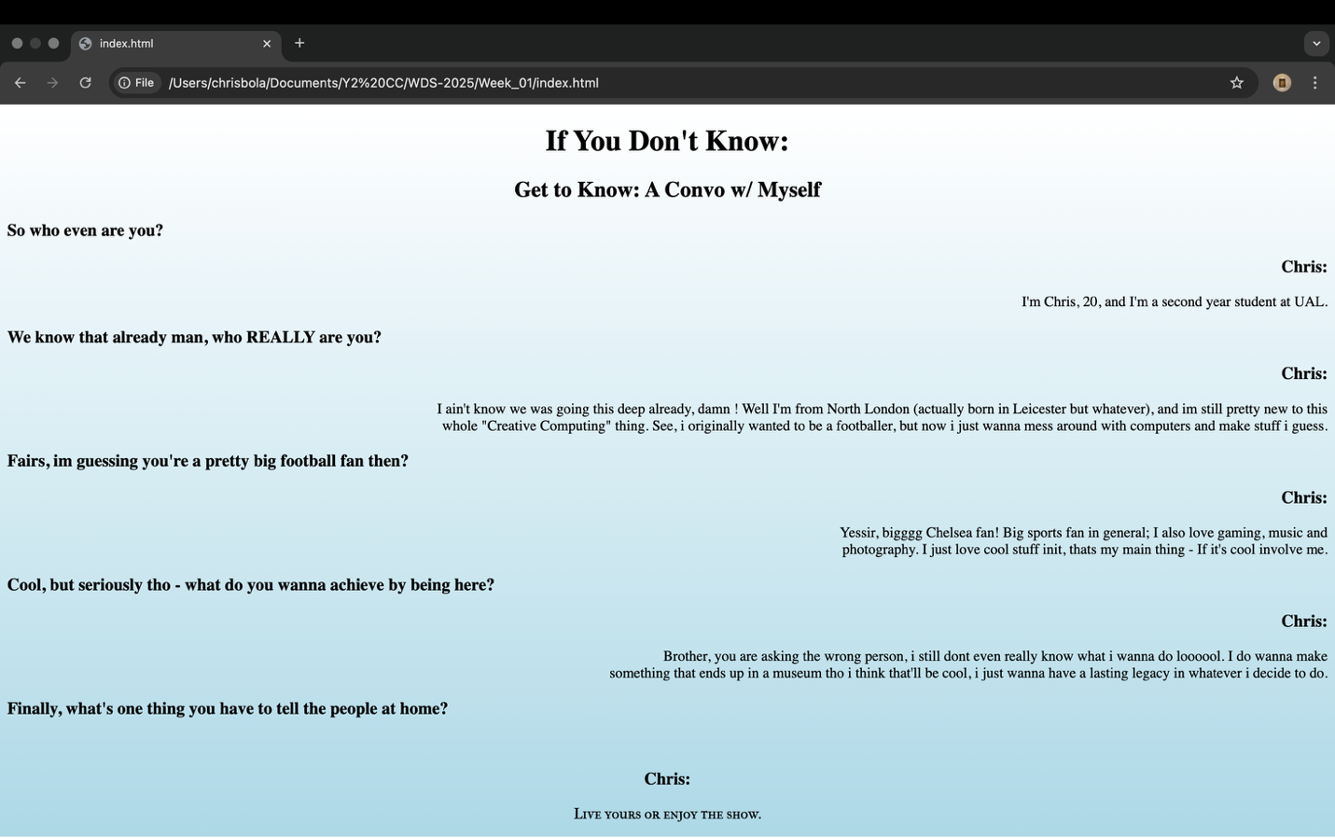
How to improve? Want more accessibility; site for accessible backgrounds; choose between 3 options potentially? Live dialogue experience; gradient shifts + words fade in/out + typing animation; like a messaging sort of thing
Know it would require some js

https://css-tricks.com/snippets/css/typewriter-effect/ changed elements to keep simpler
knew I would be communicating with html through javascript https://www.w3schools.com/html/html_scripts.asp

